**CST-361 Design Patterns in Java**

**Student** **Name**: Michael Weaver

**Project** **Title**: Data Access Layer Patterns

**Date**: 01/20/2019

**GitHub URL**: <https://github.com/battousairurik/CST361_Design_Patterns_In_Java>

Sub-folder: Activity 5 Code and Documentation

ER Diagram

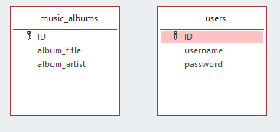

Console Test Class

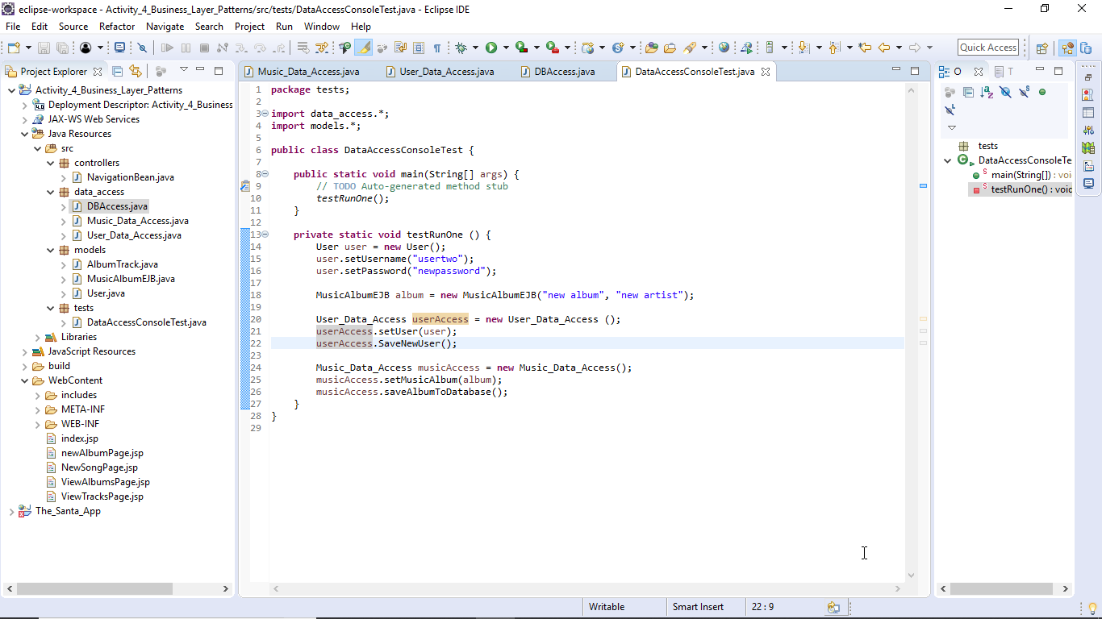

DB Access class

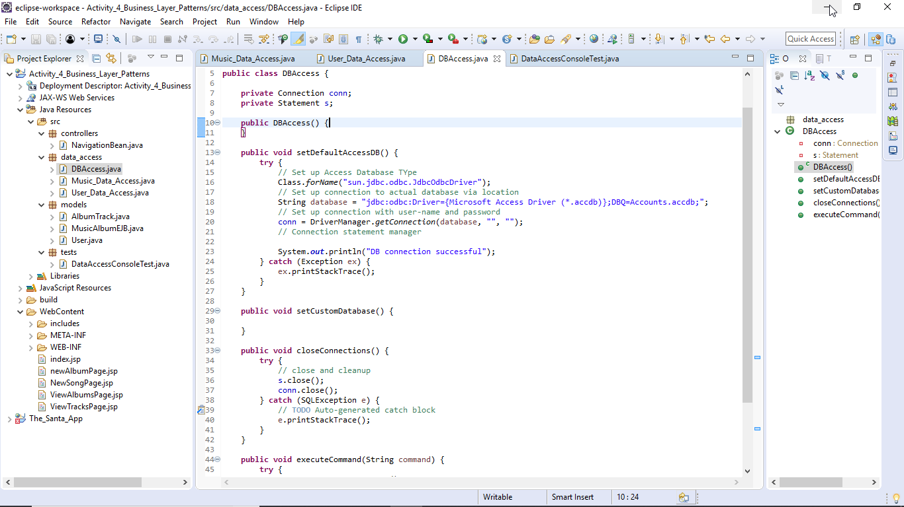

User Data Access Class

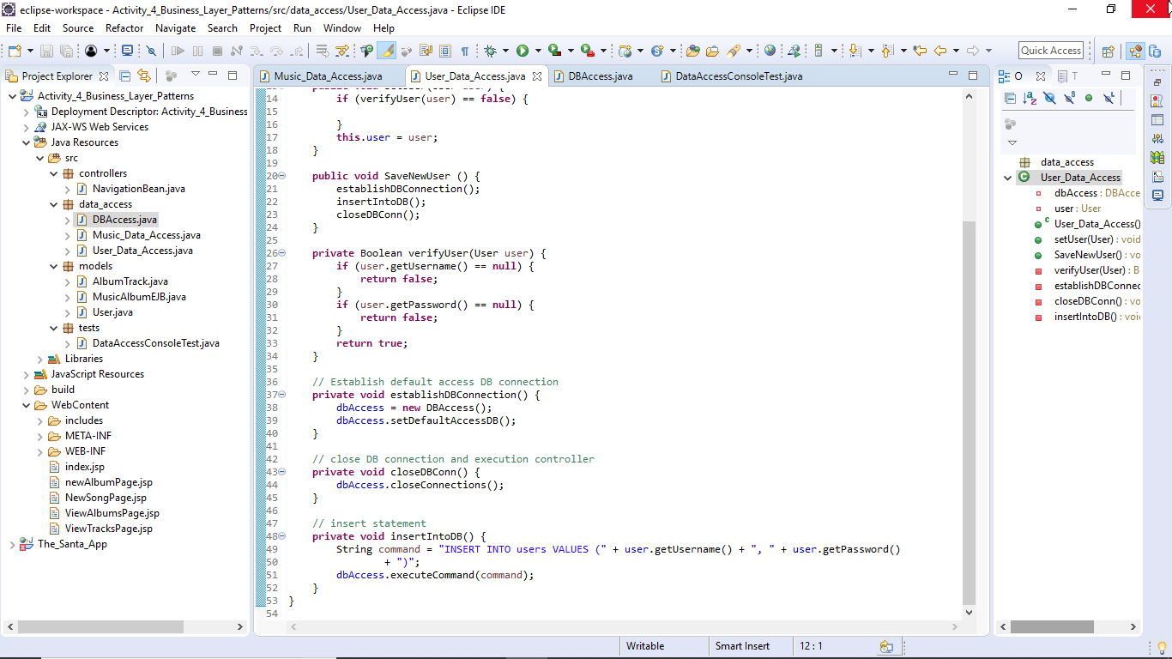

Album Class Access Class

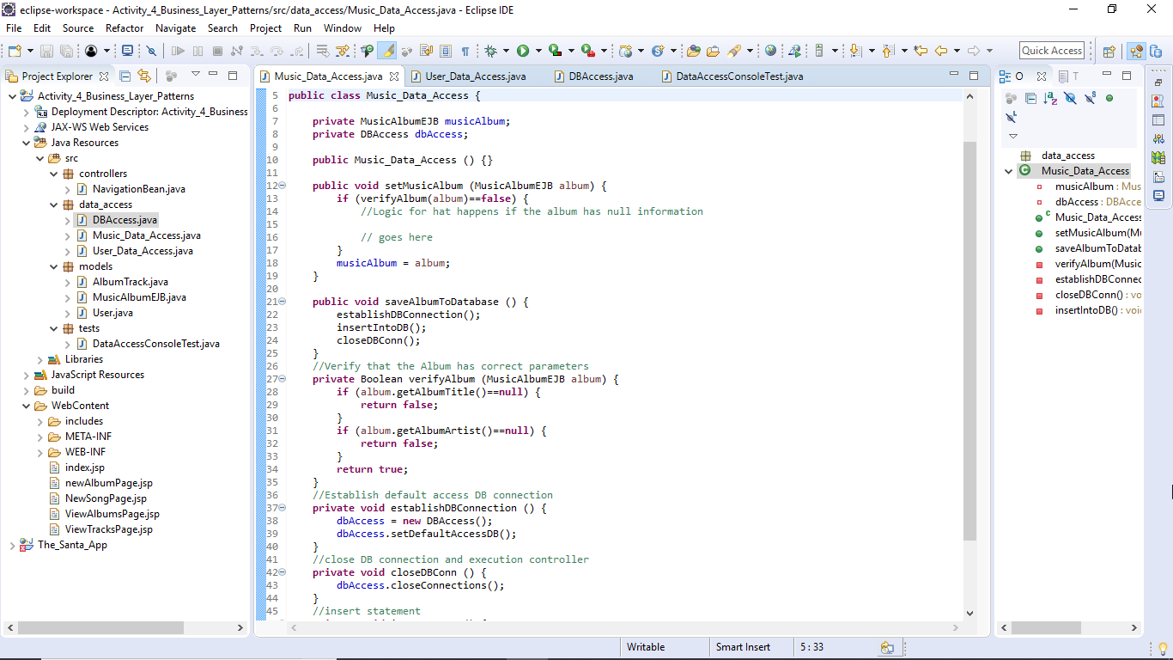

Issues

A null pointer is thrown when the application attempts to execute a statement to the database.

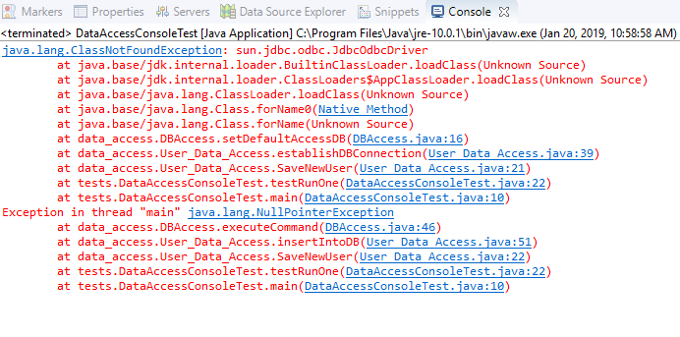

Final Thoughts

The Activity, for the most part, was a success. With a bit of tweaking it would gain full functionality.

A to do list would be as follows:

* Ensure correct database connectivity
* Solve null pointer exception
* Ensure that insert statements execute as needed
* Add additional CRUD statements to the DAO as needed for larger project capabilities